Outside Scholarship Tip Sheet

Researching Scholarships

- Start Early – more time means more options and better preparation
- Get Organized – keep a calendar of deadlines, keep a spreadsheet, notebook or file system
- Seek Help Early – give your references plenty of time to respond, be sure to thank them
- Actively Research – scholarship information will not just come to you, you must seek it
- Expand Research – college scholarship page, civic groups, employers, etc.
- Don’t Pay – never pay for scholarship information or to apply to scholarships
- Keep Materials On Hand – transcripts, recommendation letters, resume, etc.
- Follow Instructions – do exactly what you are asked to do – no more, no less
- Proofread – check for clarity of content, legibility, accuracy & completeness
- Submit Early – being early makes a favourable impression
- Keep Copies – hold onto a copy of everything you send & record date sent
- Be Patient & Persevere – it takes a lot of work & effort and there are no guarantees

Know Your Key Dates

The most important step you can take in your scholarship search and application process is to know your key dates and deadlines. You should be working at least one month ahead on scholarships (ie. – it’s March, you should be working to complete scholarships due in April). You should ask references early for letters and provide them with a copy of Scholarship Reference Form so they have an understanding of the scholarship and requirements.

Scholarship Databases:

- School Website – guidance will be regularly adding scholarship opportunities on the school site. The page can be found under the tab “Quick Links” & “Guidance”. https://secure1.nbed.nb.ca/sites/ASD-W/harveyhighschool/Pages/default.aspx
- Anglophone School District West – this has a list of scholarship opportunities for students in our school district. The list is organized by month and updated regularly. http://web1.nbed.nb.ca/sites/ASD-W/scholarships/Pages/default.aspx
- ScholarTree – a site dedicated to reducing student debt in Canada by making scholarships more accessible. www.ScholarTree.ca
- Scholarships Canada – after creating an account, students are matched with relevant scholarships and bursaries. https://www.scholarshipscanada.com/Index.aspx
- Yconic – A student community offering scholarships and peer-to-peer support. https://yconic.com/
- Student Financial Assistance – information and tools designed to help students save, plan, and pay for post-secondary education. https://www.canada.ca/en/services/jobs/education/student-financial-aid.html
- Student Financial Services – one application allows students to be considered for assistance from both the Government of New Brunswick and the Government of Canada. https://www2.gnb.ca/content/gnb/en/departments/post-secondary_education_training_and_labour/Skills/content/FinancialSupport/StudentFinancialServices.html
- Individual Post-Secondary Site – check the scholarship site for the school you plan to attend.

Need tips for writing a Scholarship Essay? Start here:

http://www.universitylanguage.com/guides/how-to-write-an-essay-for-a-scholarship/

http://www.scholarships.com/financial-aid/college-scholarships/scholarship-application-strategies/top-10-tips-for-writing-effective-scholarship-essays

http://geediting.com/7-steps-to-writing-a-winning-scholarship-essay/

Scholarship Search 101:

The following questions serve as prompts to get you thinking about the information you need to apply for scholarships

What is your average?
Do you take part in any extracurricular activities?
Do you have any special or unique skills?
Are you or your parent(s) employed? By whom? Do those employers offer scholarships?
What are your long-term goals? How would you like to be a positive influence in the world?

Scholarship Reference Form:

Complete and give a copy of this form to anyone who is willing to provide you a good reference. This will include information about yourself, post-secondary plans, and scholarship name and details.

You can access this on our school website so that it is a fillable form or get a paper copy from guidance.

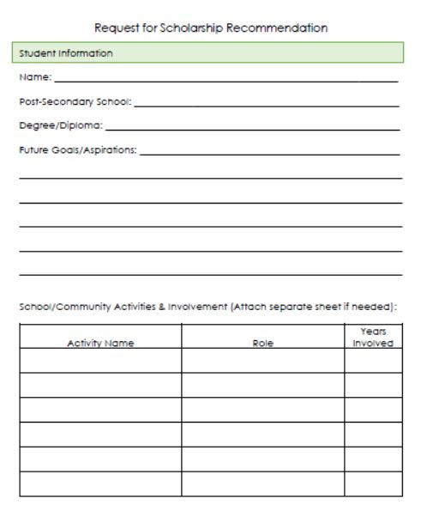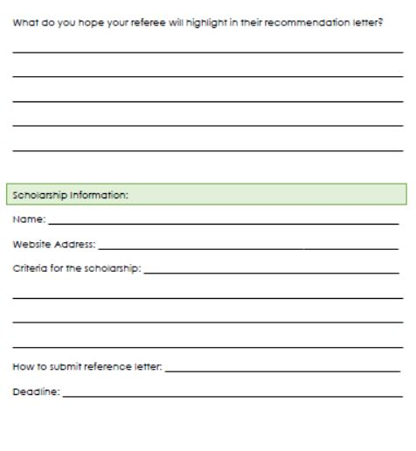

Need Assistance?

Check with guidance if you have any questions or concerns when working on a scholarship or trying to find scholarships that pertain to you.

